Weds 30th Oct 2013
Today the volleyball team went to the far end of the island to present the Life Home Project with their cheque for 250,000 Baht.
A fascinating place where mothers and their children, infected with HiV can find refuge and treatment.
At the time of our visit there were only two mothers and 14 children. Many mothers, receiving proper treatment have been returned to the community to lead normal lives. However, most of the children are orphans and need proper fulltime care.
Now that the Project has received our cash injection, they will be able to effect some much needed repairs, and take in more victims of this terrible affliction.
My sincere thanks to all the donors, both at the event itself, and those that enabled us to make the trip to Pattaya to participate.
These pictures are all courtesy of BullseyeMaco who did sterling work as cameraman for the afternoon.

Attached Images
- 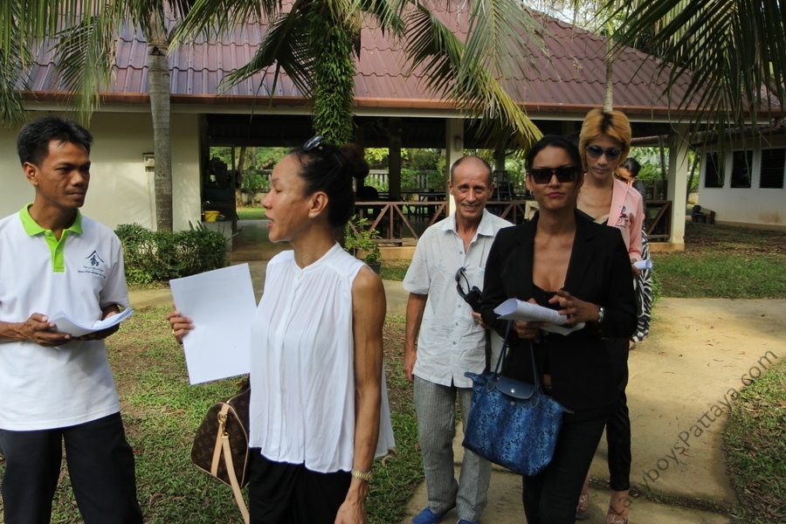
- 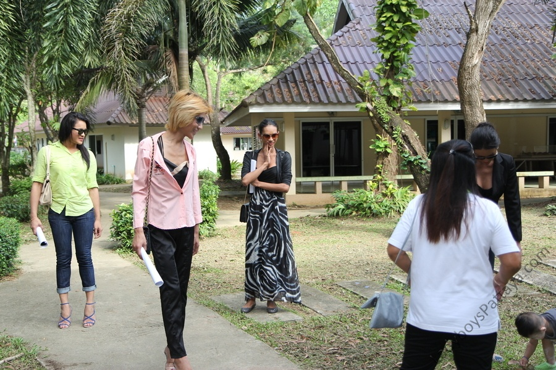
- 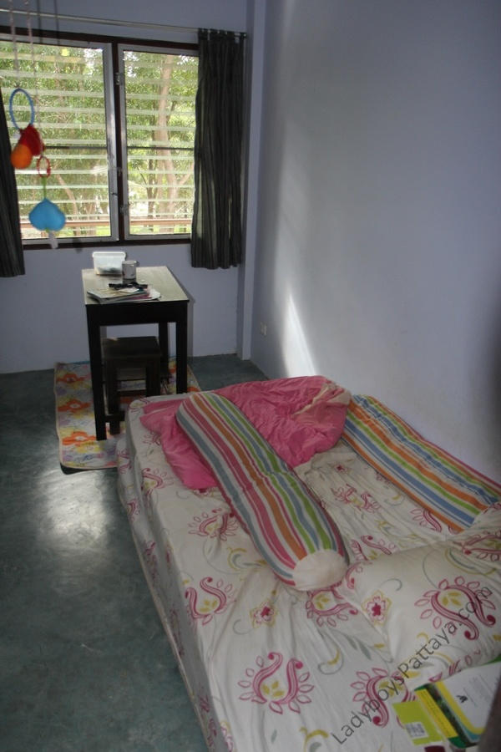

- 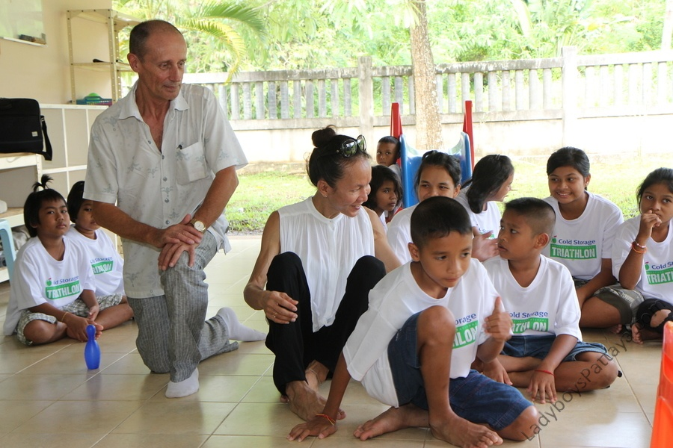
- 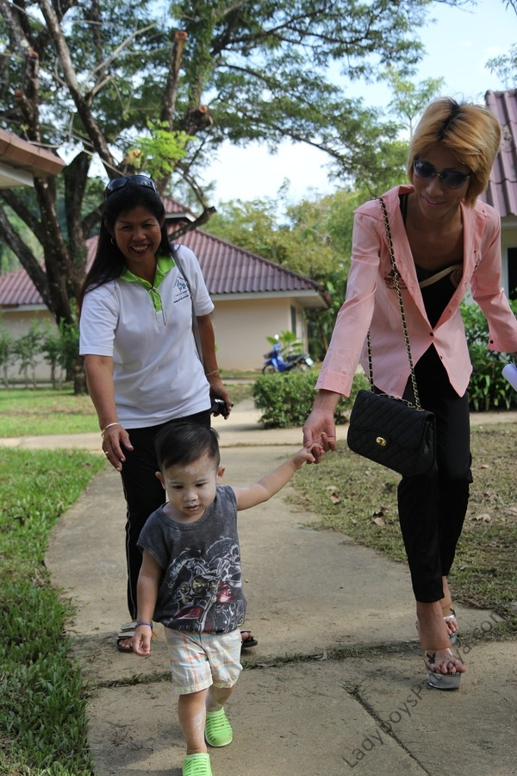
- 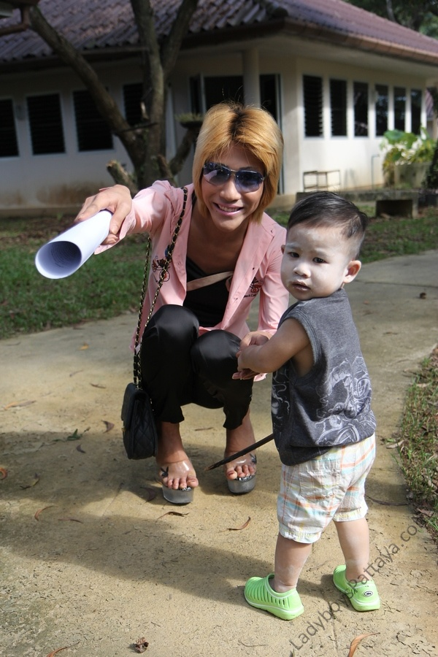
- 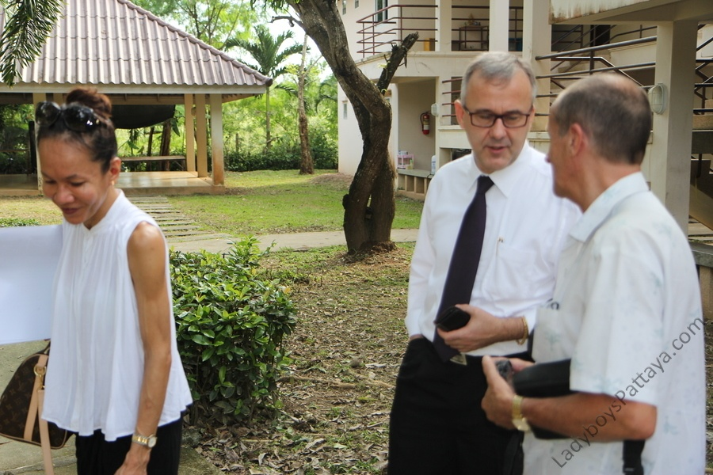

I enjoyed the cake!

Attached Images
- 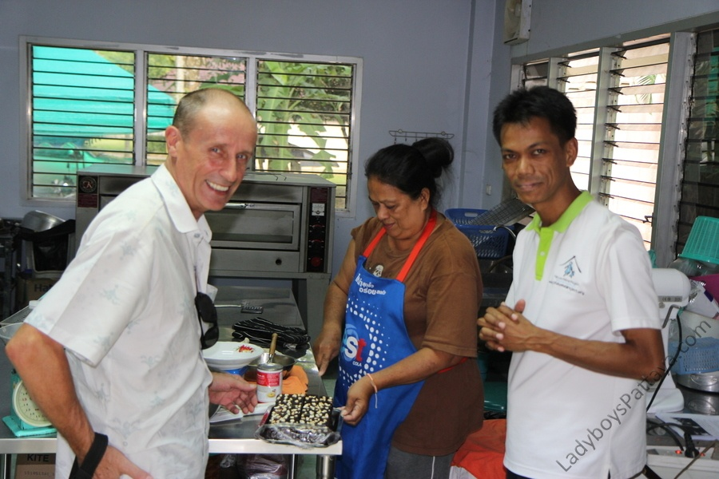
- 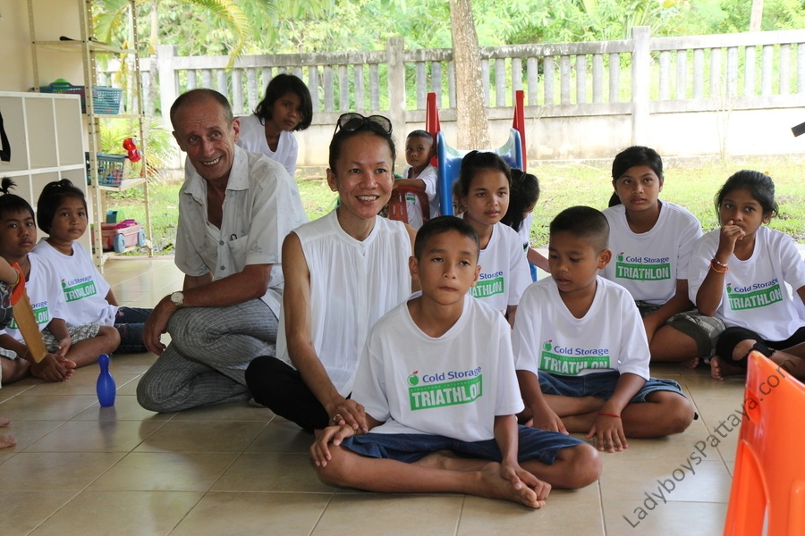
- 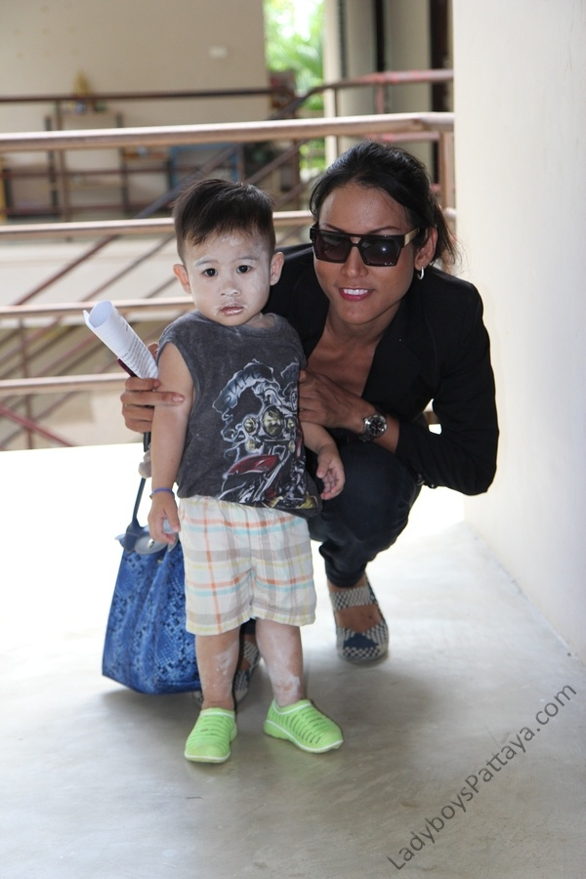
Finally it was time for the cheque presentation

Attached Images
- 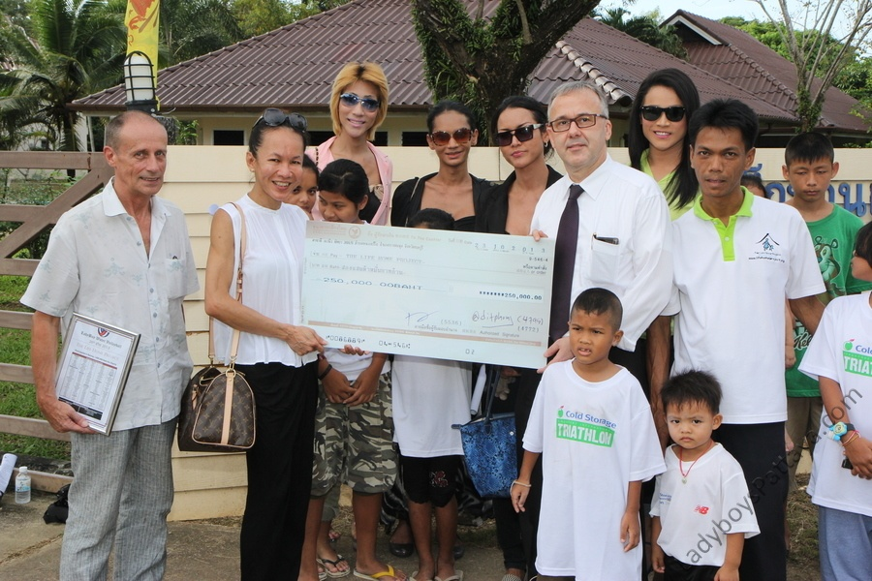
- 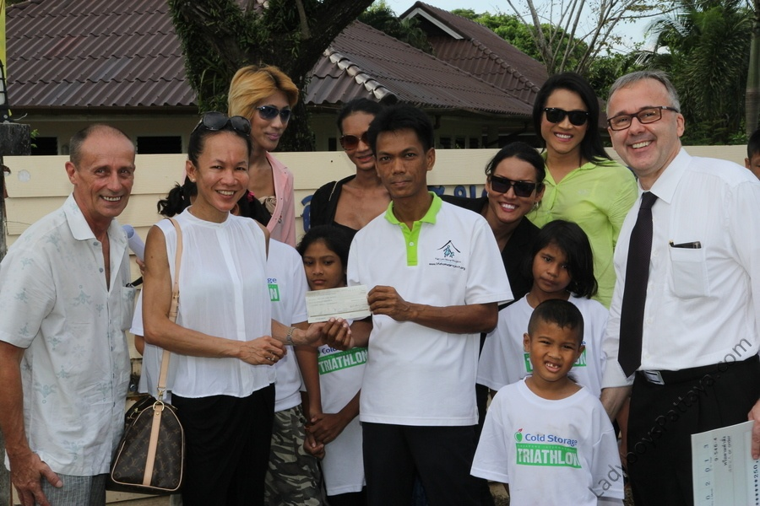
- 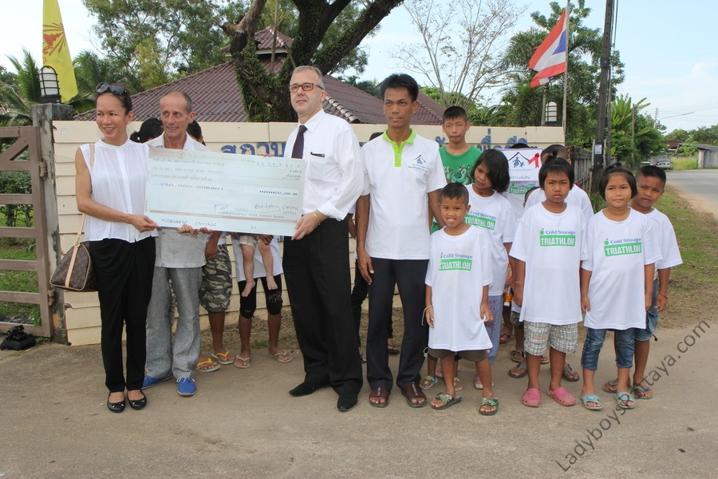
- I noticed many of the repairs that needed attention:

- Broken roofs
- 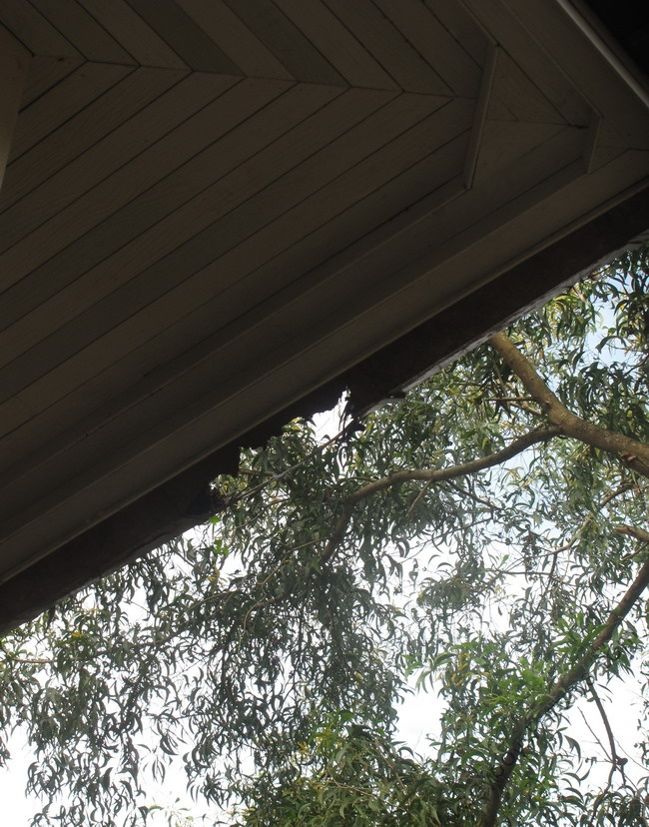

- Damp patches
- 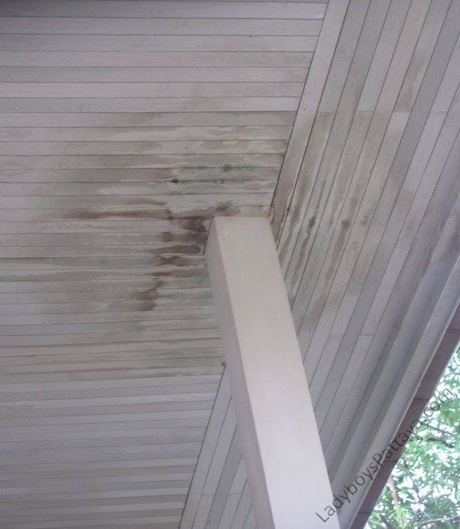

- Dripping taps and showers
- 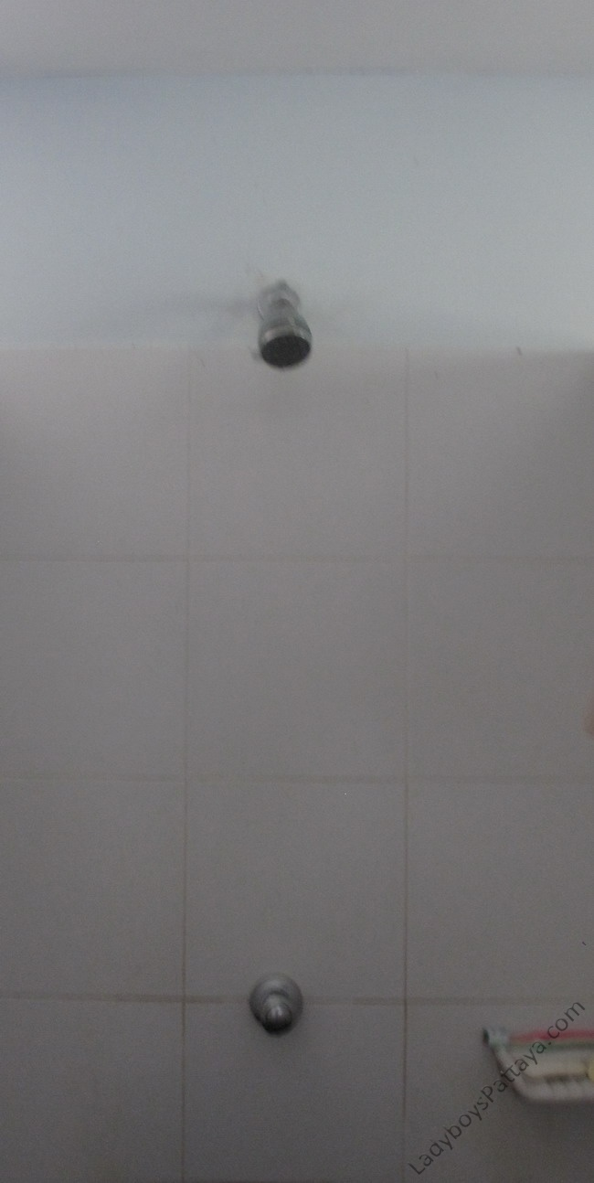
- This little soldier wanted to hold the girls hands the whole time
- 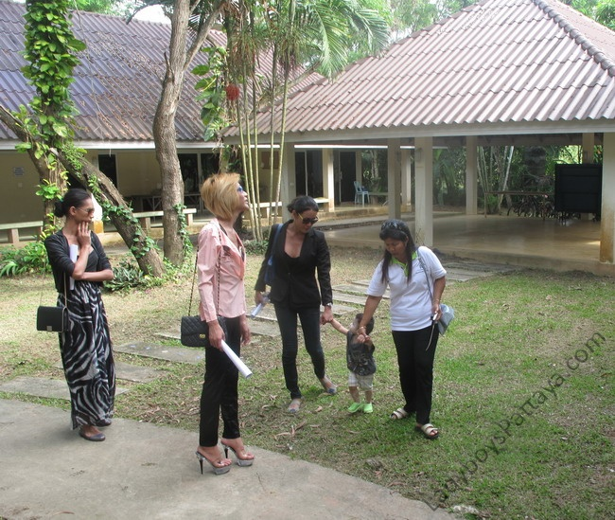

- All the kids were adorable
- 