Indiana Jones and Filters of Water

LadyBoy Water Volley Ball, in 2013, contributed 250,000 Baht to Rotary Water4Life Project.
Supplying Water Filter systems to remote villages in Thailand.
The Filters are comprised of 2 interlocking 7 litre containers.
The upper container has a central ceramic filter that removes all contaminants and allows the clean, drinkable, water to drip into the lower container which has a dispenser tap.

The units last for about 5 years and the Ceramic filter will be good for 30,000 litres.
The drip filter process takes about 6 hours. The user fills it, or tops it up, before going to bed so that in the morning they have 7 litres of drinking water. In the morning they top it up to ensure they have 7 litres for the evening.

Units cost about 1,000 Baht, Village needs 250 filters. LBWVB donated 250,000 Baht for a village.

The Trip
It was decided to invite some of the LBWVB Team players to join us on the expedition.
Without them there would be no event and it helps them to see where their efforts help other Thais.
Stringfellows and Kings Bar were the teams selected

Thanks to Bob of Stringfellows, and Dave of Kings Bar, for financing their representative team visits.

A MiniVan was hired and accommodation booked in the nearest town – Chantaburi – about 200 Kms SE of Pattaya.

Pick up started at 2pm on Saturday and Itim and Gif climbed aboard at Soi 13/1.
Next stop was Soi 8 to pick up Hom and Tom.
Finally the minivan collected me on Highway 36.

The drive was an experience and the driver must have been a survivor of the Japanese Air Force!
Never had so many close shave in one trip – he seemed to find extra traffic lanes out of nowhere.
Somehow the Thais just slept through the motoring mayhem.

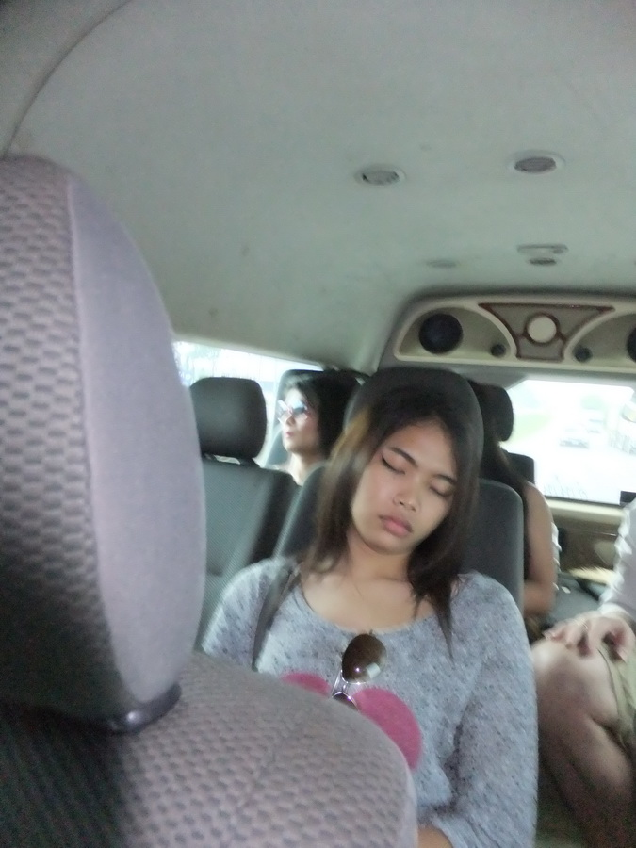

As usual the Thai habit for requiring food manifested itself after about 1 hour.
We decided that we needed something stronger to calm our nerves so bought 12 cans of Leo.
We boarded the minivan once again, once the brake calipers had stopped glowing.

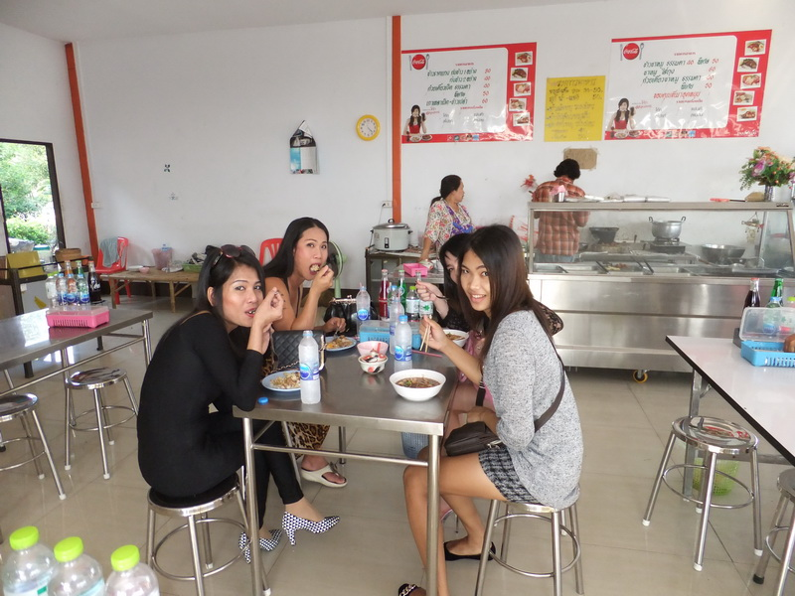

The expedition arrived in Chantaburi about 5pm.
Our party met up with the local Rotary Club members who would be our guides and hosts.
Modern, clean Hotel with a beer garden serving food.

Dinner was a terrific selection of Thai and Western food and Paulaner beer.
After dinner we decided to venture into the town’s nightlife. We booked a Baht Bus which was a very old Datsun. The problem was that he was entering the Dakar Rally so had 4 spare wheels in the back. He took us to a Thai beer garden and charged us 100 Baht which was fair.

The expedition breakfast, and briefing, was at 7am so the night finished at a reasonable time – well for some of us! The Thais carried on and did not return until 2am.

Waking up at 6.30 time for ablutions and packing. The shower had more controls than an A380 Airbus. Initial fault diagnosis was that there was no water. The irony of no water, when we are delivering water filters, was not lost.

But the wash hand basin was working. Various valves, turned clock wise and anti clockwise, produced no result. Finally found a switch and the water flowed. One other of our party had a similar problem but he banged on an adjoining room and asked to use their shower. The cheek of it……

7am Breakfast – our possible last civilized meal. Much coffee consumed.
8am Climbed aboard the minivan for a 30 minute drive to a jetty at the most inland point of the delta.

The water filters arrived by truck and we were all loaded onto our water craft – powered by a very old V8.

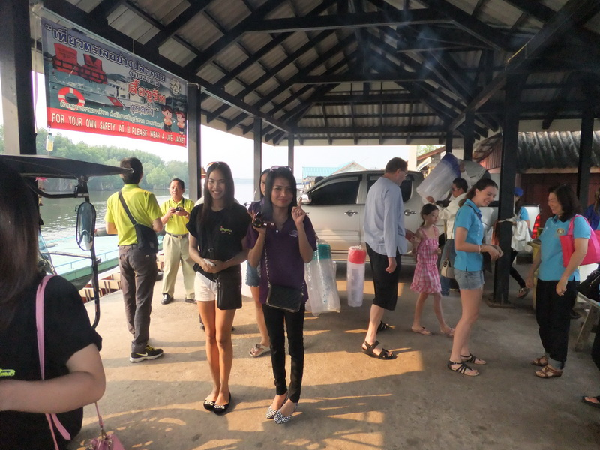

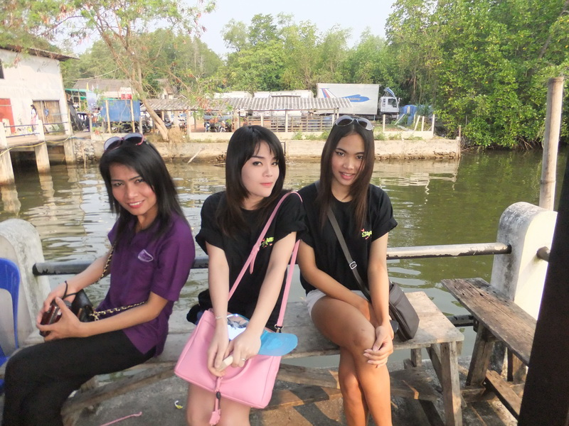

The village was only accessible by boat as the village rests in the mangrove swamps South West of Chantaburi on the river delta.

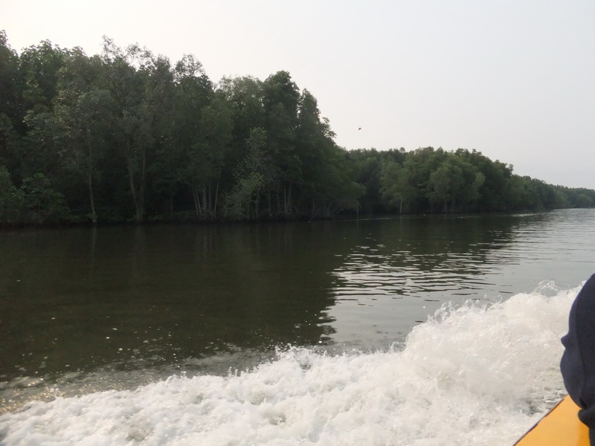

The original inhabitants of this village were ‘Sea Gypsies’ and ‘Chinese Pirates’

Going down river there were many sights including what looked like a plastic bottle farm. The bottles are used as floats and have ‘lines’ attached with bait to encourage mollusks to grow. Not a 711 in sight.

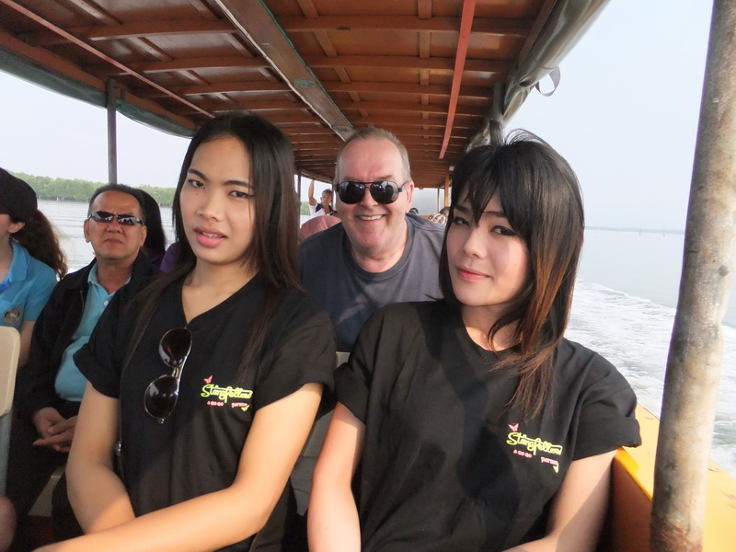

Nearly an hour down river we arrived at our village. Dwellings all built on stilts above the brackish water.
We were ushered into the Village Meeting Hall where many residents were beginning to congregate.

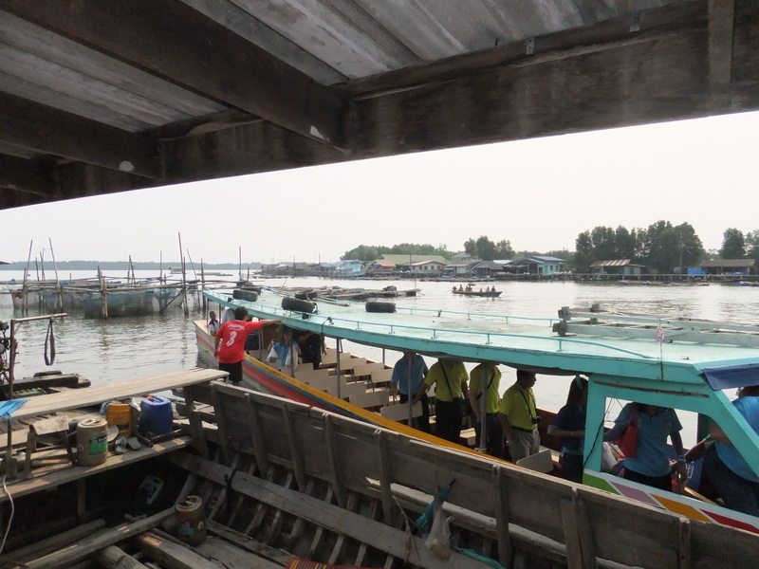

Everyone in the party was employed in assembling the 250 Water Filters. It was a small production line.

Once a good few had been correctly assembled the distribution commenced. One unit per household.

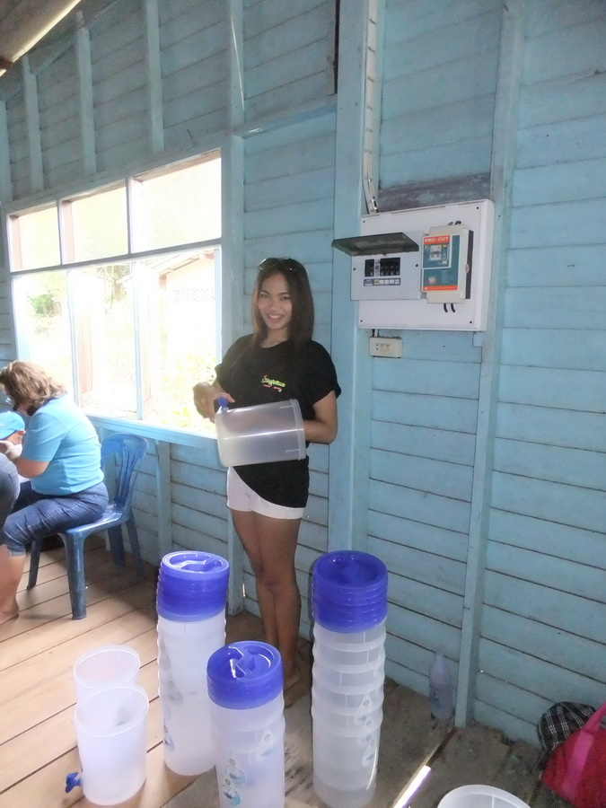

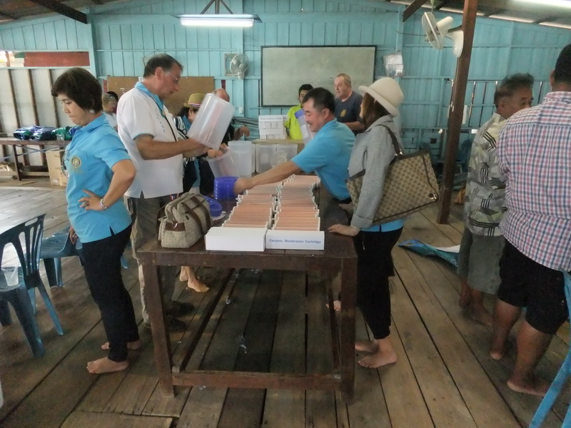

The villagers were instructed in the use and care of the filters. Only rain run off water may be used. The river/mangrove swamp Brackish water contains soluble salt which cannot be filtered out.

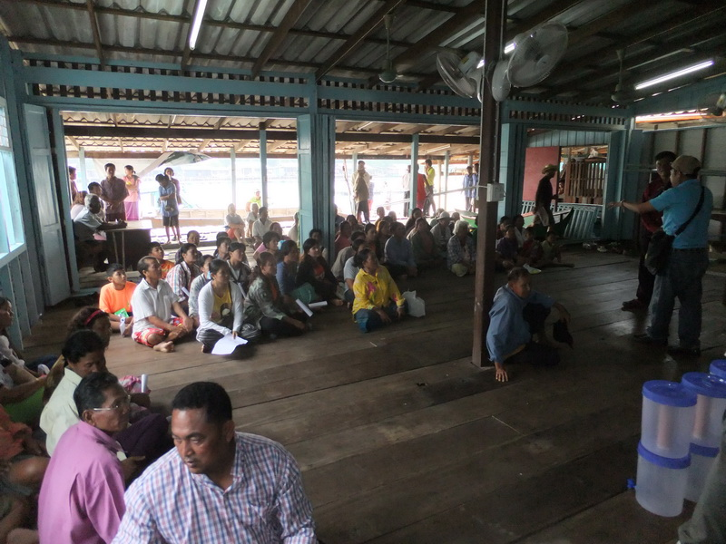

The village elder made a speech and acknowledged the contribution of our LadyBoy team members.
Each family was called out by name and a representative of that family had to show their ID to receive their filter.

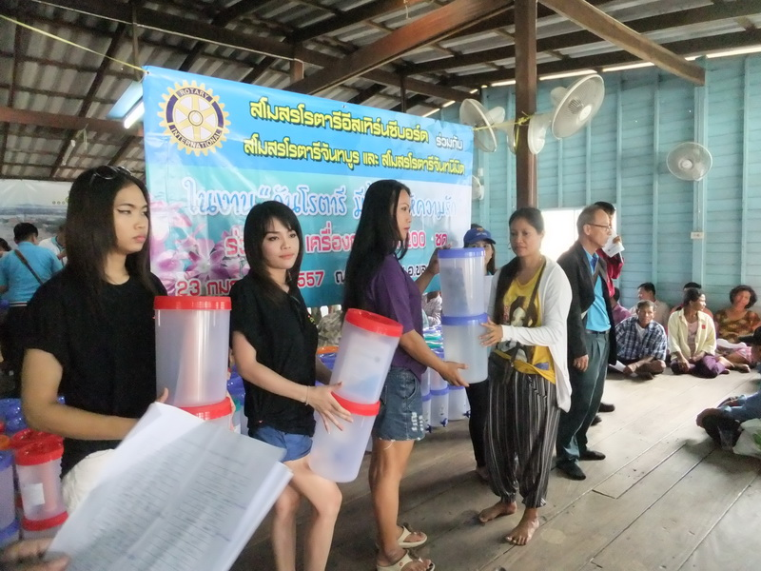

The teams helped distribute the filters with terrific smiles from the recipients.
By 12 midday we were finished and boarded our river craft back to civilization.

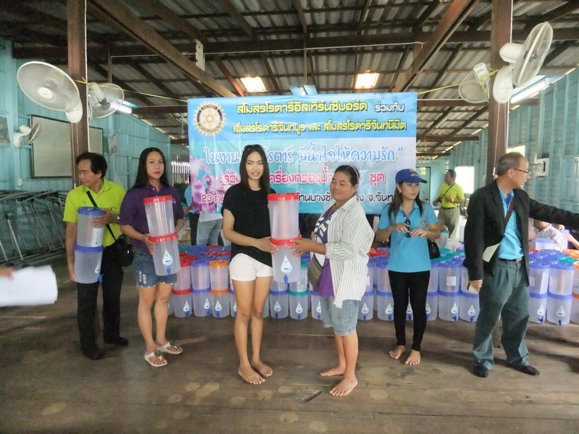

On the return journey I sat next to an American exchange student. Her exchange was organized by Rotary International. A very bright, young girl who had been here for 5 months, staying with a Thai family, while teaching at a school. She explained that Thailand was her 7th choice of location and was initially shocked when she arrived. Since arriving she has become entranced with Thailand and the people. She does not want to return to the US and her experience has changed her outlook on life.

She told me that for 2 weeks she stuck to a Thai budget of 100 Baht a day and survived comfortably.
Concerned now that, upon returning to the US, she would feel uncomfortable about paying 20/30$ for items. She was proud of the fact that her most expensive shirt purchase was 300 Baht.

How we all take drinking water for granted and yet so many people still have no regular supply.
Thanks to all the Sponsors, in 2013, for making this contribution possible. Great job.

