We have nearly managed to visit all the benefiting Charities.

The visits are twofold.

- It is important to follow up on how our contributions are used
- It is terrific to have the Bar’s teams involved so that they can see 1st hand what it is really all about.

Baby Boom – Josh, his wife Pooh, Apple and Off
Sensations – Scott, Paeng and Poppy

This is a clinic providing free medication to Thai people, with HIV, here in Pattaya.
They also treat foreigners whom are expected to pay.

Not really an opportunity for photos as patient’s identity is carefully protected.

We were asked to visit only between 4.15pm and 6.00pm while no patients in attendance.

Everything went well until the local police stopped the Sensation’s team for a random check.
This always brings home how LBs are tolerated, but not 100% accepted, in Thai society.

The visit was an education to all of us.

Dr Philippe is a humanitarian, who has worked in Pattaya for 16 years. He works hard to help people with HIV, with fantastic up to date information about the disease and its treatment.

There is always one enormous problem with each Charity visit.

How can we continue to support all of them?

Our 250,000 Baht contribution keeps his clinic funded for about 1.5 weeks!

Dr Philippe, for those who were at the 2013 event will know, is fluent in both English and Thai.

He explained a great deal to all of us and was a font of information.

If anyone has doubts as to the needs to use protection, for casual sex, they need to visit Dr Philippe and hear, first hand, from an expert.

Not only did the 2 bars attend but also a lady from Denmark doing research for her Master’s Degree in Anthropology.

It was not the most exciting visit but it was the most educational and again shows how we all help.

I am a lay person, not a qualified physician, so my notes are just that – they are not an approved medical report. It is a compilation so that it is difficult to rephrase some inserts.

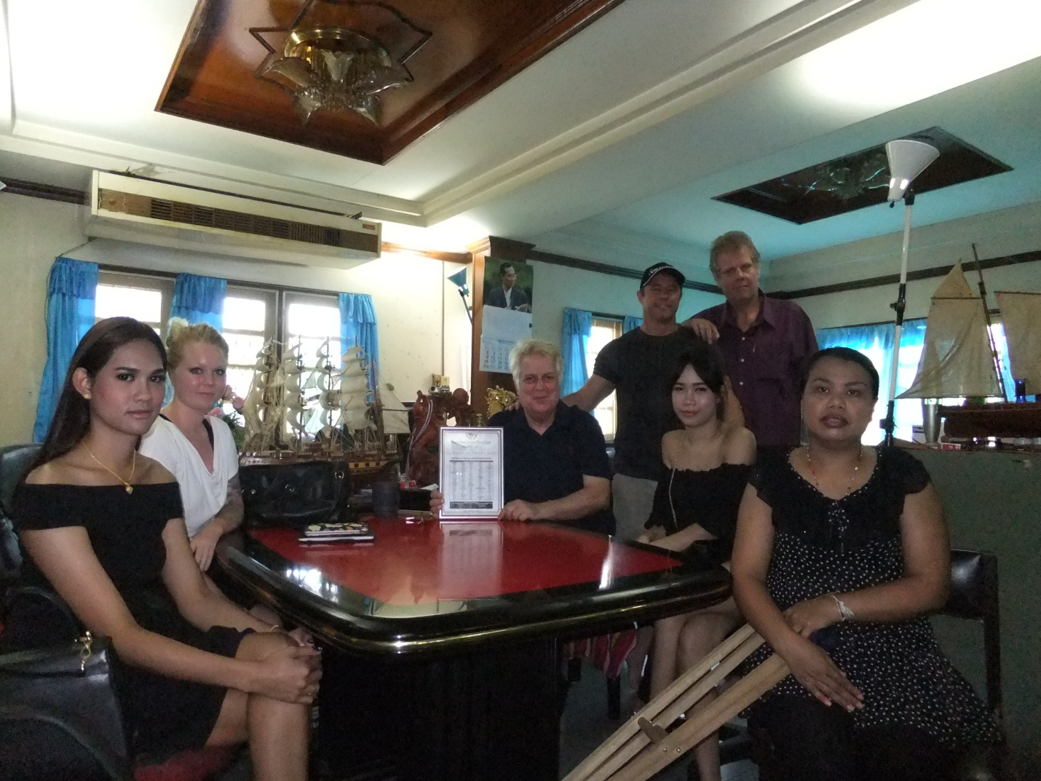

Some facts and figures.
The clinic has had 2334 Patients - 450 are currently being treated.
The age spread is from 19 to 80. 60% of patients are male which includes gay and LBs.

There is also a worldwide marked increase in the incidence of Syphilis combined with HIV

HIV test - 2 levels. If patient suspects infection 1st test may prove negative so then a secondary test required.
Incubation period from infection can be as low as 3 weeks for detection but certainly 3 months.
Besides these INDIRECT Serology tests (AntiBodies against HIV in blood) can now use DIRECT tests (detecting the presence of HIV in blood either PCR or p24 ag or " Dual Tests.
As an opening question Dr Philippe was asked about:

Is a Blood test recommended every 3 months?

His response, in strongest terms, was:

What is recommended is safe sex with a condom.
If condom is broken then think of nPEP = Nonoccupational Postexposure Prophylaxis within 24 hours and certainly within 3 days of the accident. ARV Rx for 4 weeks, to PREVENT HIV transmission;

If risks taken, have a blood check !

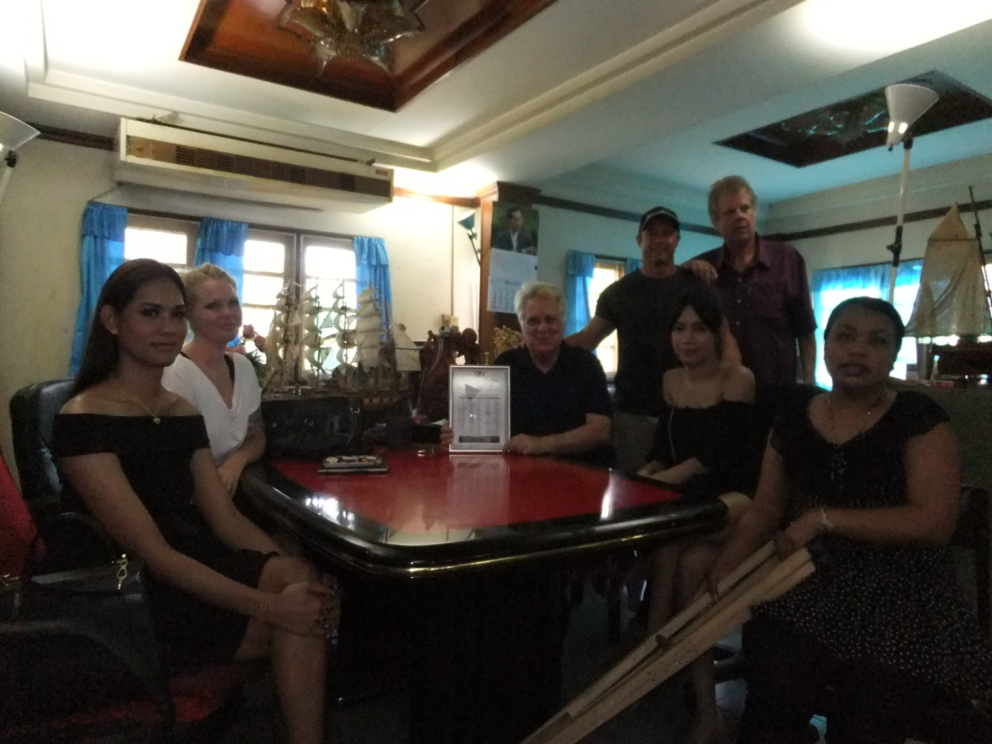

HIV Treatment

Today Thais can be treated for free under the National Health System.

They need to enroll in the scheme so that each visit costs 30 Baht.
They can only be treated where they are registered. So a person registered in Nakhon Nowhere, but living in Pattaya, would not be entitled to the 30 Baht scheme.

Not all AntiRetro Viral drugs are free under the National Health scheme.

To be entitled to the ‘free’ treatment the patient’s CD4 count/MM3must be less than 350.

1,000 is the CD4 level for a normal healthy person.

Patient’ receiving earlier treatment as provided by Heartt2000, reduces side effects and provides a better long term outcome. They also have a better chance of becoming non- contagious.

Level 1
If treated correctly, can live a normal life with HIV.
The term level one is now reclassified to persons who still have high CD4 but are Asymptomatic

They may not infect other people if good compliance with ARVs, and HIV Viral Load in blood is UnDetectable < 20 copies / ml x 2 and > 6 Months, and no active genital STD,
Not 100 % (condom still recommended if with unknown partner)

(Note - Especially HPTN 052 study shows - Google search)

1st line ARV drugs cost about 1,000 to 2,000 Baht per month, per patient, and are free to Thais.

The clinic is filling the gap where an infected Thai cannot get free treatment via the NH scheme.

Many patients incur TB even after level one drugs taken as it is an Opportunistic Infection (OI).
Any diseases must be treated before ARV’s given.

To avoid "IRIS " = Immune Reconstitution Inflammatory Syndrome )
possibly occurring if an OI, such as TB, is not yet treated dried up BEFORE ARV Rx is given.

Level 2
If patient’s have an allergy to the treatment, or intolerance, the cost of alternatives may rise to a few thousand Baht per month – 3,000/5,000 per patient per month.

Level 3
If a patient has a CD4 count below 350 then they may need “RED’s”
Raltegravir / Etravirine / Darunavir-ritonavir
These cost 40,000 Baht per month
There are non-generic commercial names

Isentress* / Intelence* / Prezista*-Norvir*

The price, in Thailand, decreased recently but still around 34,000 THB / Month
These drugs can be cheaper with Indian generics but they are not yet available in Thailand.

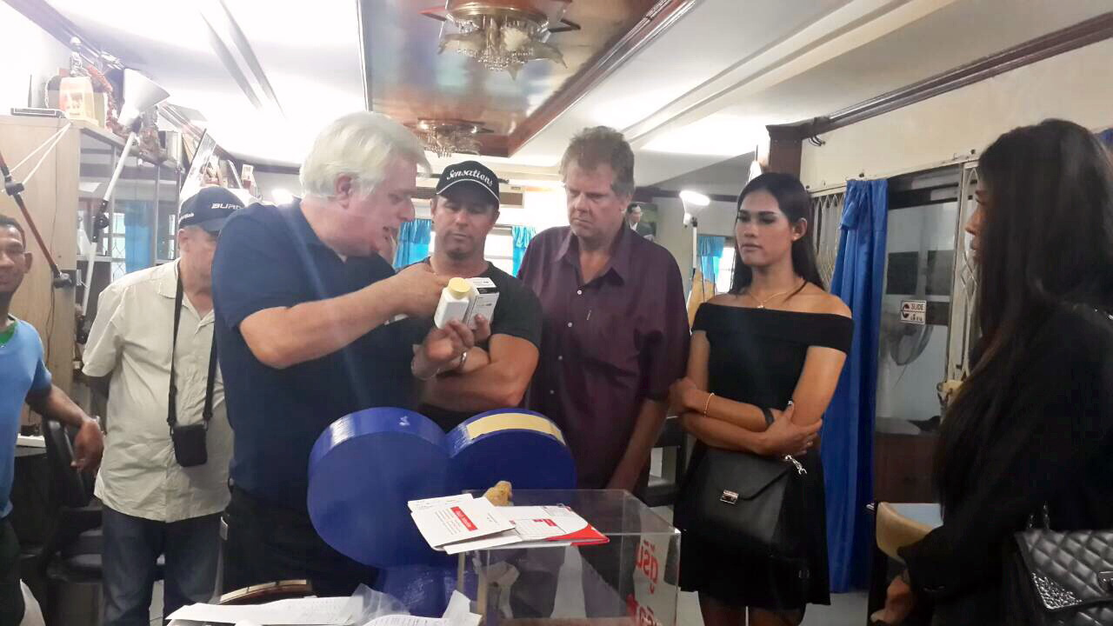
www.heartt2000.org
www.okwecare.com

