As many of you are aware Temptations and Cockatoo Ladyboy Bars joined forces to take part in the LadyBoy charity Water Volley Ball (LBWVB) competition held last October in Pattaya.
This special event helped to raise just over 1 million Baht for Thailand based charities, with us helping to raise a 250,000 baht donation for our chosen charity.
The Camillian Home for Children living with disabilities, which is based near Bangkok.
http://www.camillianhomelatkrabang.org/
Please read our trip report below to see how everyone's hard work, sponsorship and donations have made these children's lives just that little bit better...
REPORT

We arrived at The Camillian home at 11.30am, on Wednesday 7th May 2014, where we were warmly welcomed by Nat, Head of Communication and Development at the home.
She explained how the home not only cares for mentally and physically disabled children, and young adults, but also those living with HIV & AIDS.

Camillian is also officially recognized as a non-formal school by the Thai Ministry of education, So not only does it care for, in a medical sense, but also assists in the personal development of the children and therefore helps to structure a better future for them.
75 children are cared for on site, of whom, 25 are resident at the home, all of whom require 24hr assistance.
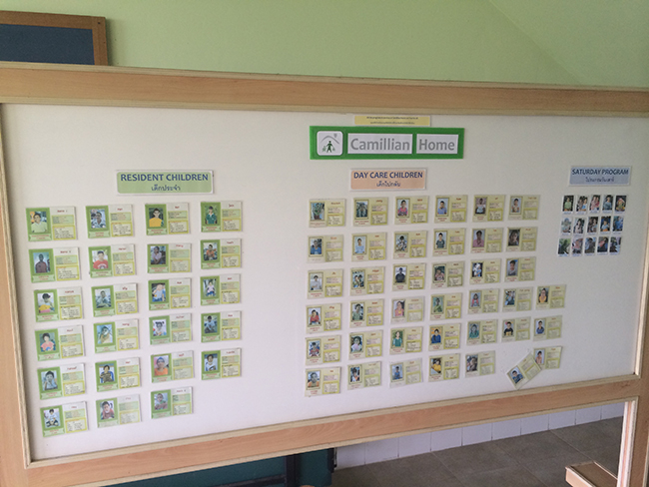
A weekend Saturday program is also available.
Camillian's daycare program provides parents the opportunity to continue working, and earn a living to take care of themselves and their families.
Camillian Home also assists the parents themselves by helping pay for and maintain the food carts and stalls so many of them use to make their basic living.

We were then given a guided tour of the home.
We began with the class rooms where English, Thai, Maths, Science, art and ethics are all taught on a daily basis.
The classes are conducted exactly the same as in "regular" schools with lesson plans, lesson structure and discipline all maintained at a high level.

The Occupational therapy (OT) treatment room was our next destination.
OT focuses on helping people with physical, sensory, or cognitive disabilities to be as independent as possible in all areas of their lives.
OT can help children with various needs to improve their cognitive, physical, sensory, and motor skills and enhance their self-esteem and sense of accomplishment.

The medical department was visited next and was a very poignant moment in the visit.
Here the children, with severe disabilities conditions and HIV/AIDs, are cared for.
The courage of some of the patients was inspirational with one 10yr old lad (who had leg and hip problems) telling Katy from Temptations that he wanted to be a Mai Thai fighter when he gets older!

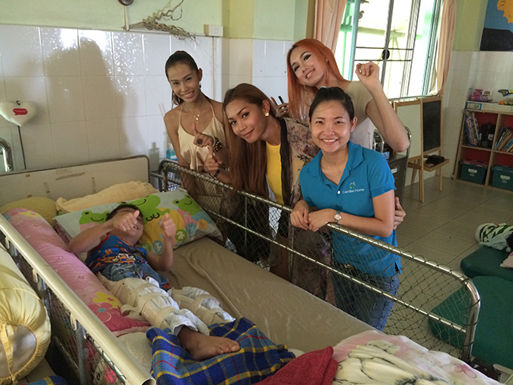

We were then treated to a fantastic lunch with everyone and it gave some of the children the chance to thank the girls for their help in raising the fantastic contribution that was made.
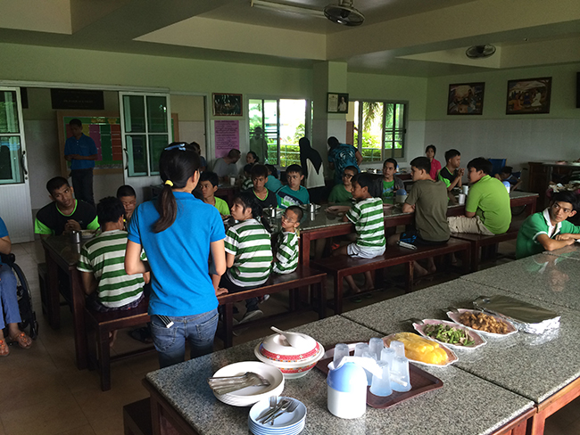

Following lunch we were given an acoustic rendition of The Everly Brothers "All I have to do is Dream" by the children in the music department. It was fantastically sung with the guitar being played brilliantly by a blind student.

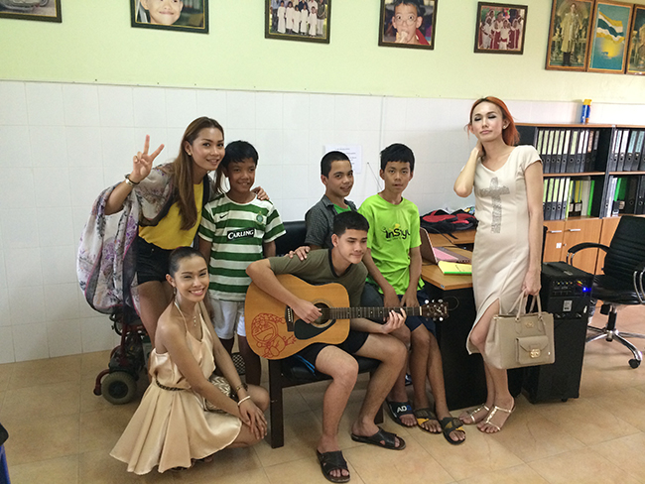

Just before the end of our stay we were taken for walk in the grounds.
We were shown the adventure playground, swimming pool and garden where the children are taught how to grow their own produce which will maybe spark an interest in farming, which we all know can be the main source of income for so many Thai families.
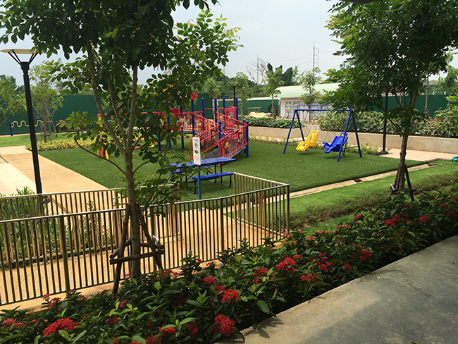
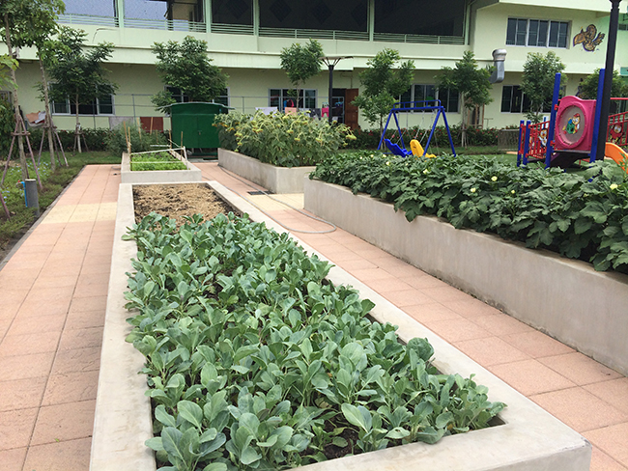
With our visit over we said our goodbyes and the children kept a lovely gesture till the end.
They presented us with a beautiful, hand drawn framed "Thank you" picture made in the art department.

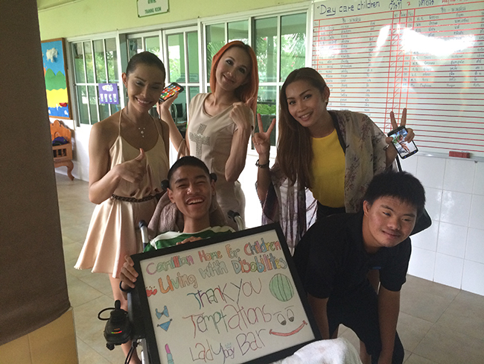

In all The Camillian home is an outstanding charity worthy of all our support.
Medical care, education and community support are all provided by the home, which is driven by a dedicated and passionate team of employees and volunteers.
With monthly running costs at 1 million Baht the home needs all the help it can get.

We would like to thank the staff and the children for making us feel so very welcome
The girls from Temptations and Cockatoo- Katy, Yoyo and Benz and also everyone for your support in last year's event.
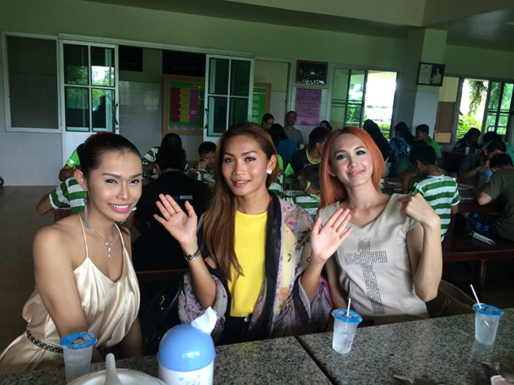

We will be proudly taking part again on 1st November 2014, so please, please help us beat last year's total so we can continue to support Camillian Care Home and help provide a better future for children living with their disabilities and their families.
An emotional and fruitful visit - we can all make a difference and have fun doing it.
Many thanks to Father Giovanni for reminding us of how we can help - a true humanitarian with a sense of humour.
His acceptance speech, in both Thai and English, meant a great deal to all who attended last year.
Tickets for the event, and Sponsorships, and Baseball Caps will be available from our bars soon.

