Can You Hear the People Sing

Back in 2012 the Pattaya Orphanage was selected as a worthy Charity to support.

Visiting the Orphanage they explained that the roof on the Deaf school was in desperate need of repair.
The existing roof had ‘sky lights’ built into the sloping roof and now there was a great deal of damp. The damp created spoors and the mould was affecting the children’s health.

Many children are not only deaf but autistic – there are about 40 children in this part of the Orphanage.

The Orphanage asked how we were raising the money? We showed them a poster of the then planned event – there was a look of shock and surprise as they read:
Lady Boy Water Volley Ball
Father Michael, the director of the orphanage, was not in the least fazed as he just looked up and said:
The Good Lord works in mysterious ways.

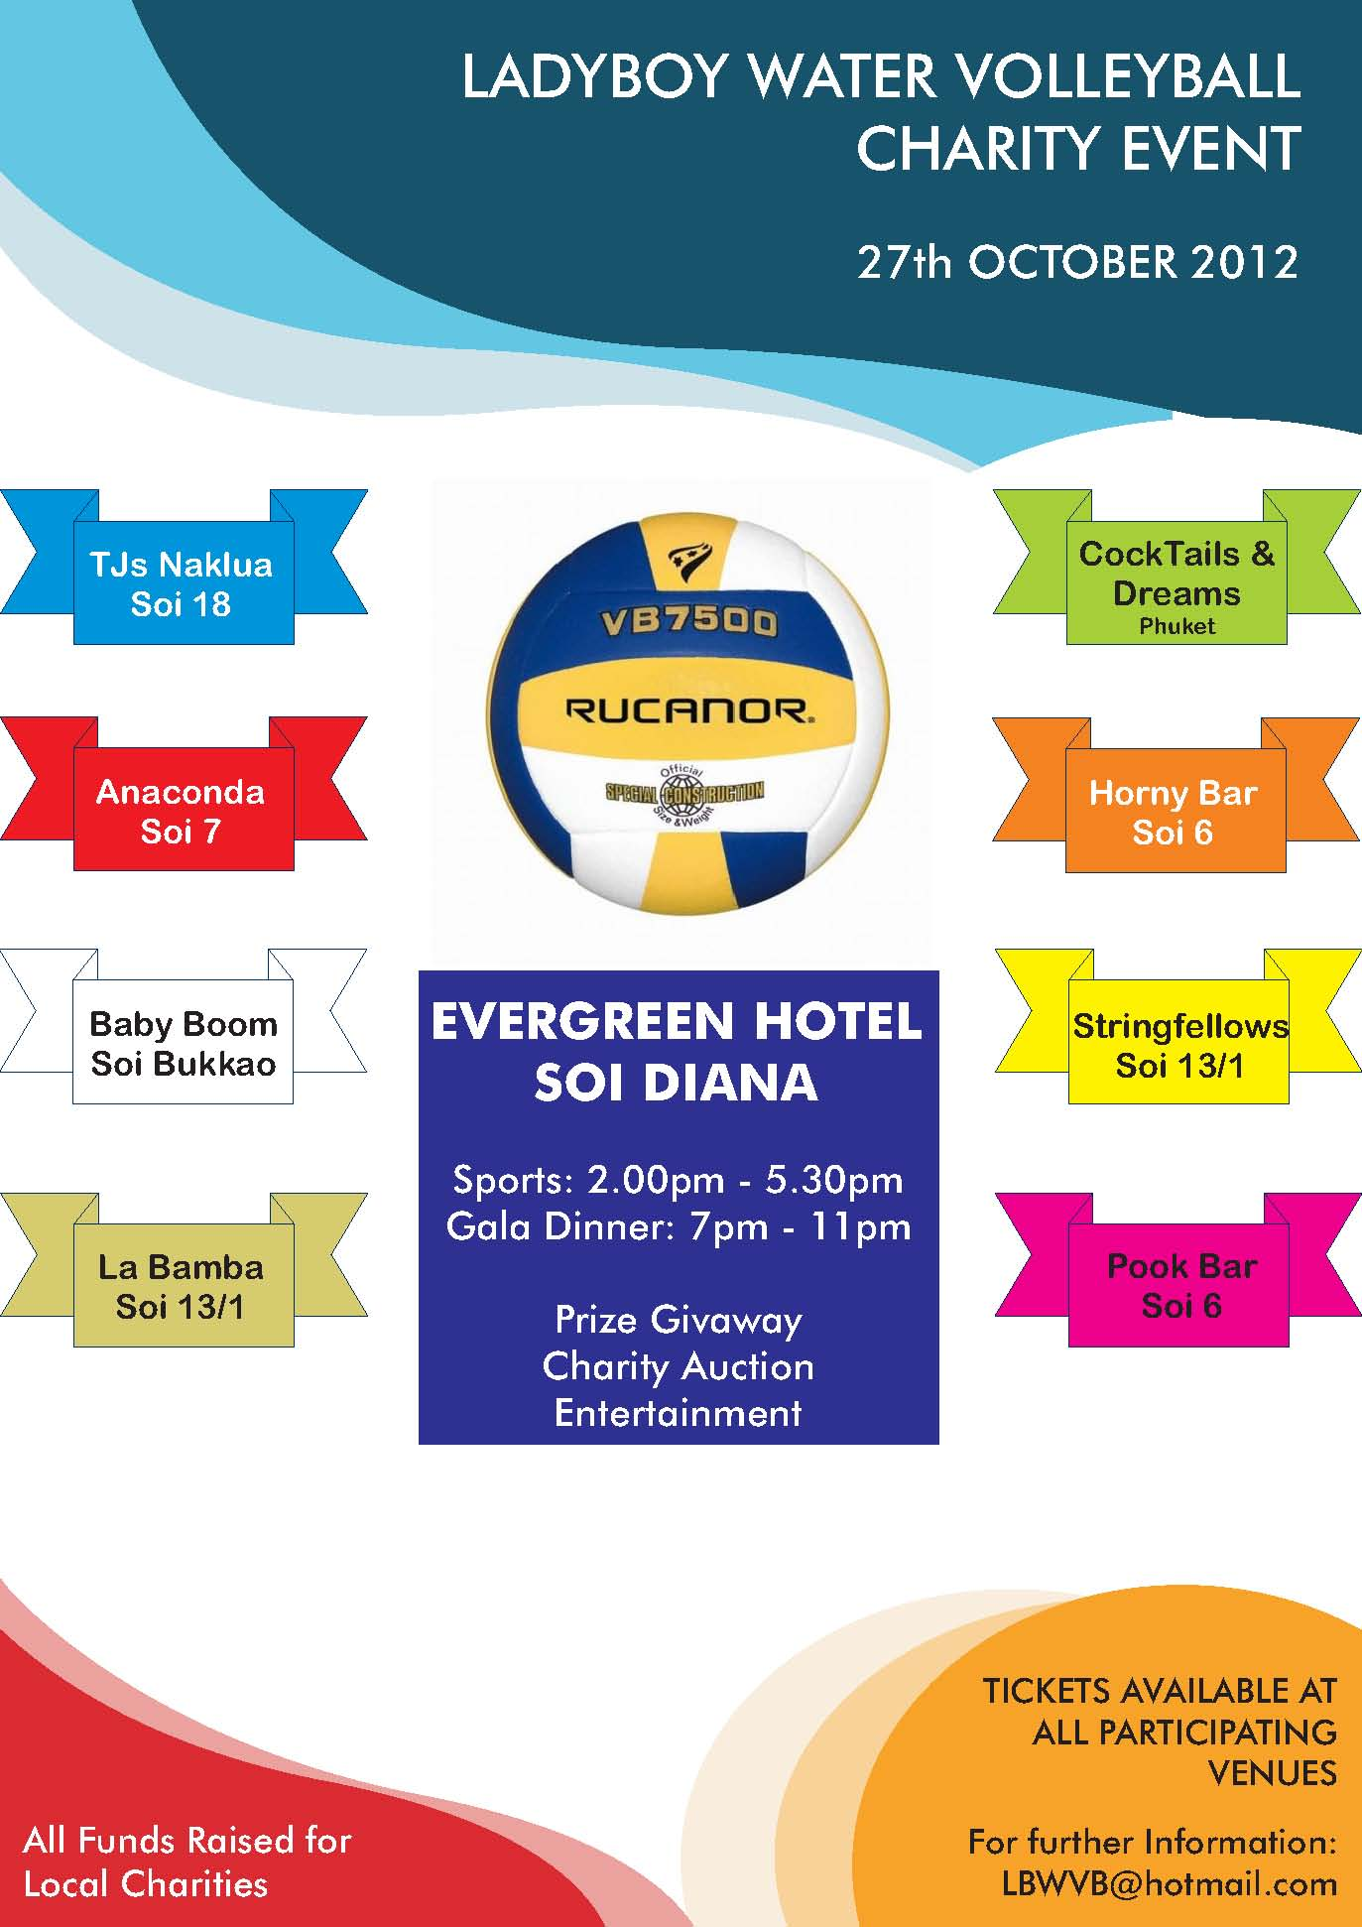

A tour of the deaf school showed the extent of the work to be done. The roof, in need of repair, covered the bathroom area and some of the classrooms. On the tour we were accompanied by nearly all the children – just like the Pied Piper of Hamlin.

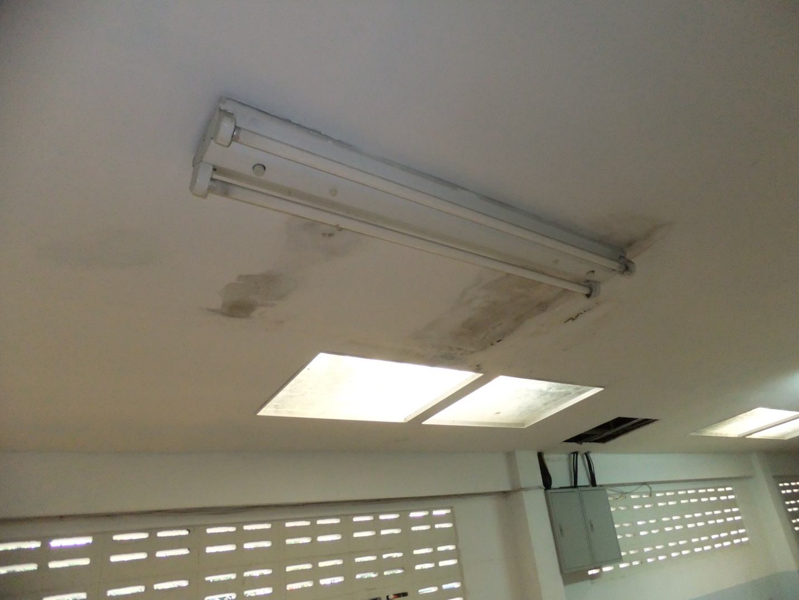

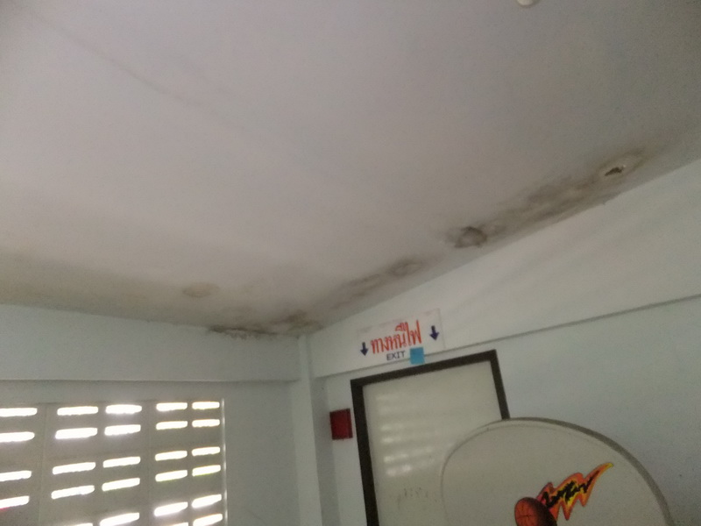
Even though they could not hear us they were still so expressive and affectionate. They like to see visitors and Farang are different. They all wanted to look at our phones, our cameras and anything else including our hairy arms!
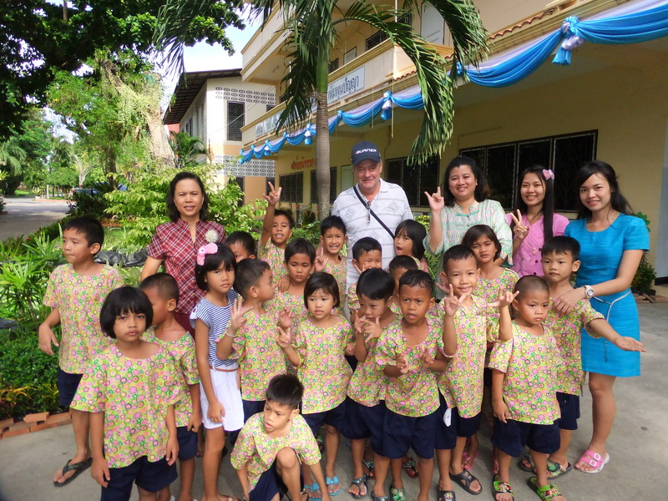

Having seen the work required we pledged to contribute from our event – at that time we estimated about 75,000 Baht.

In return I was invited to the Alankarn theatre to see the Deaf and Dumb children perform in a special anniversary show – We can hear them Sing - and see the pleasure it gives to them to do so.

2012 LBWVB event was the first ever event with many unknowns and a great deal of doubt.
Many people believed it was crazy and would never be successful.
Many believed any fund raising would not be significant.

When the event finally took place the event raised 283,000 Baht – a large part of that was from the Auction the proceeds of which would not be known until after the contributions were given to Charity.

The auction needed to be underwritten, in advance, to ensure that the cheques could be presented on the actual night.

Father Michael came to the event where he thanked all the attendees including all the team players (in Thai). Because he stayed on longer than anticipated many Auction items (of an adult nature) had to be deferred until he departed!

The Orphanage received a cheque for 125,000 Baht – well over the forecast amount.
They now had a large proportion of the funds required to complete the roof repairs.

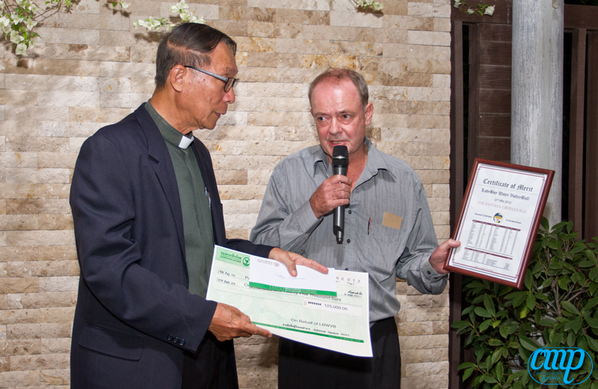

2013 came and went with another terrific Fund raiser – see other reports.

In January 2014 it was decided to revisit the Orphanage and see the work accomplished.

Team members from TJs Music Bar and La Bamba joined the visiting group.

15 liters of Ice Cream were ordered and the Ice Cream motorbike arrived at 2pm
TJs team were picked up in Naklua and we all met up with LaBamba about 3pm

Father Michael came to welcome us and was still chuckling about LadyBoy Water Volley Ball.

TJs team (Nattie and Jenny) had gone out and bought colouring books, crayons and lots of snacks
La Bamba (Nok, Nancy and Anna) brought more treats of pencils and books and fresh fruit along with their mascot dog.
The children are not allowed pets so the dog was a popular visitor.

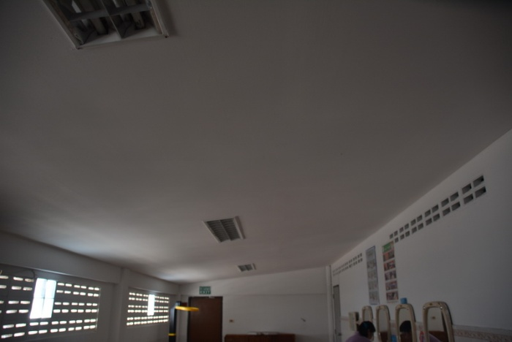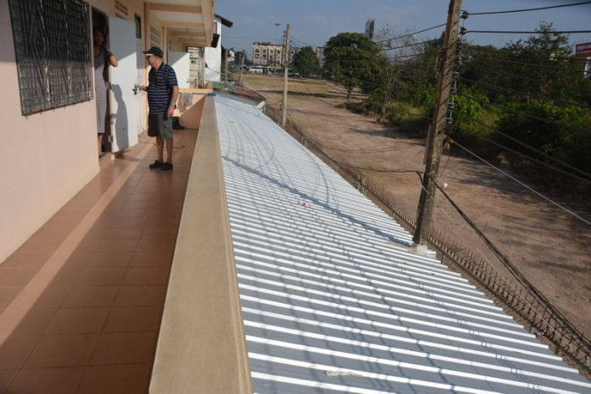

Nok, from La Bamba served the ice cream which was a big hit with all the children and the staff.

A tour of the repaired roof was given – what a difference.

Nancy, from La Bamba, was our official photographer and did an excellent job of capturing the visit.

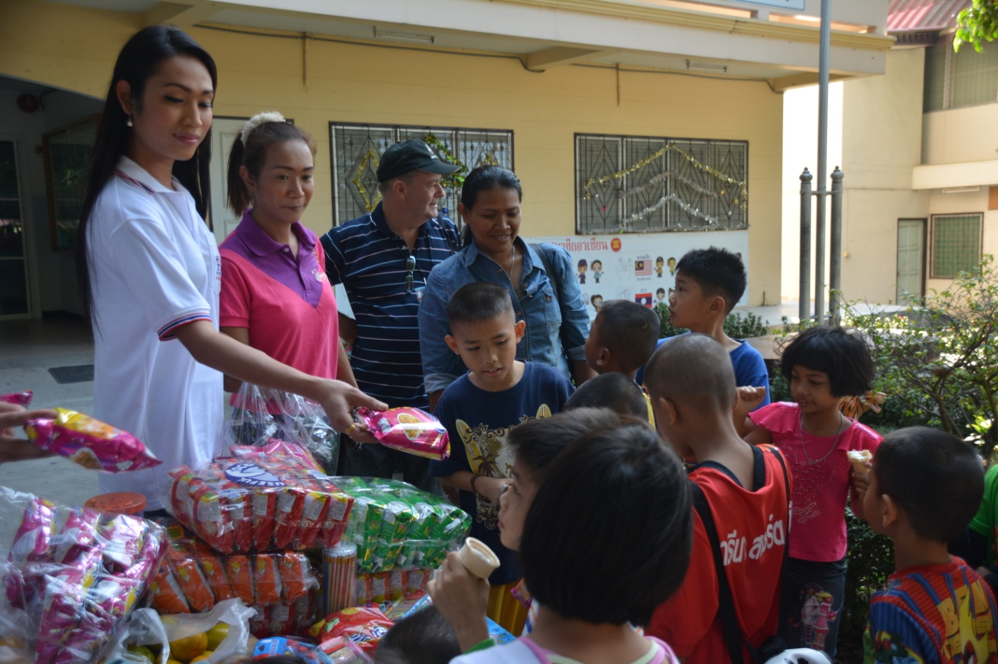

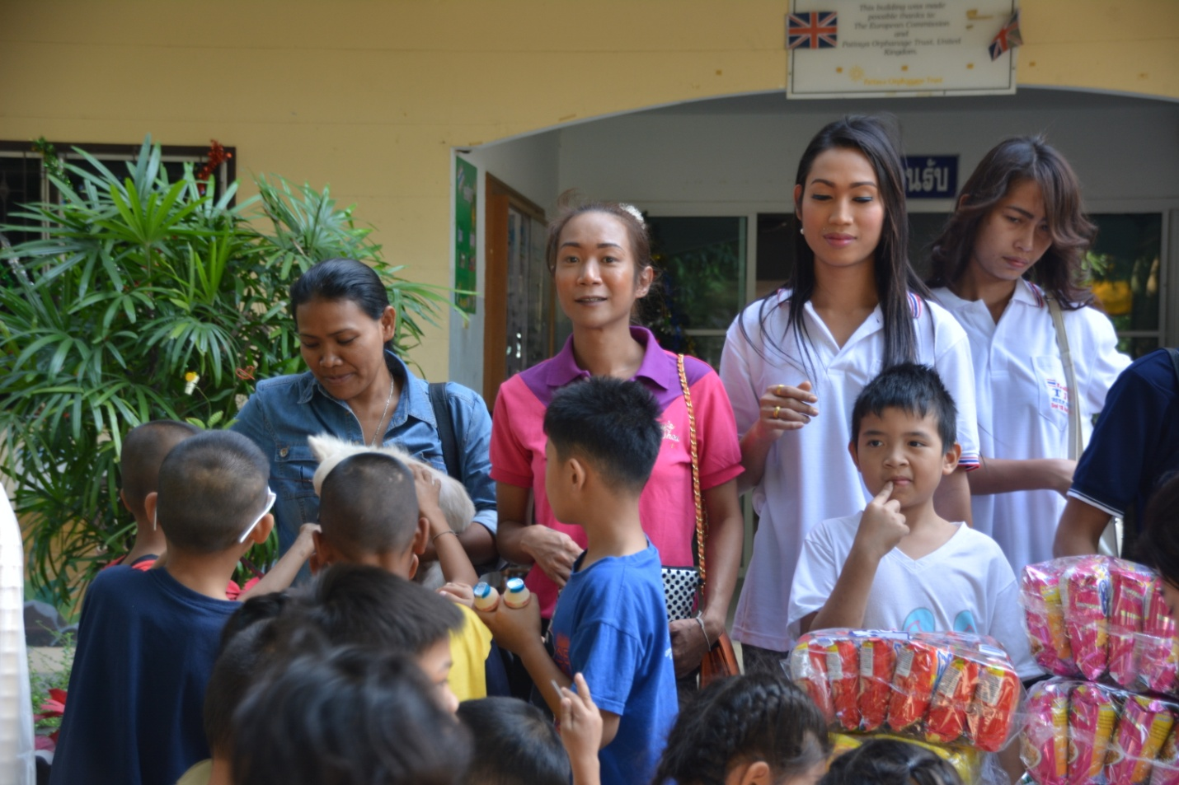

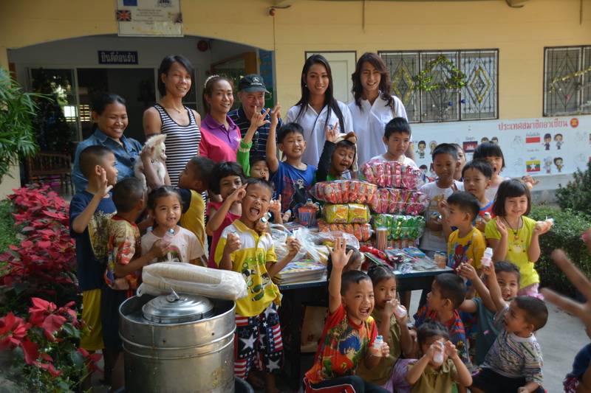
Many thanks to all those who contributed to 2012. We did make a difference.
125,000 Baht went to the Orphanage and 100,000 Baht to the Water4Life project which enabled 100 filters to be given to a village. 58,000 was carried over into 2013.

